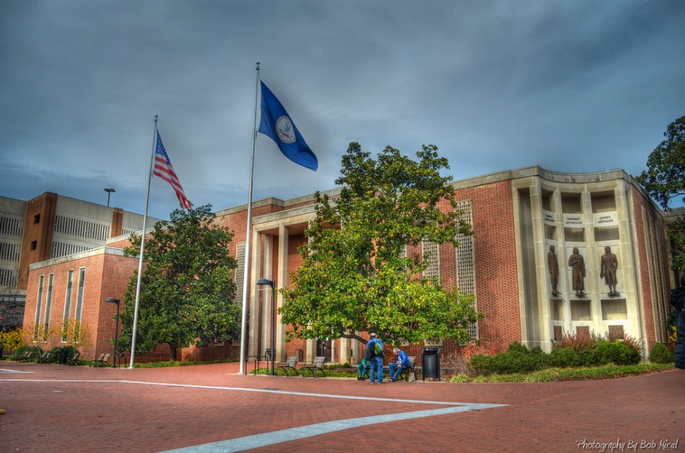

Questions? Contact Joe Platania at 434-970-3179
Charlottesville Commonwealth Attorney’s Office
Community Academy
Fall 2024

Commonwealth’s Attorney Joe Platania invites you to participate in a no-cost 7 week program designed to provide community members with an inside look at their local criminal justice system and the daily operations of the Commonwealth Attorney’s Office.
- Select Thursday’s from 6:00 – 8:30 p.m. September 12 – December 5.
- Must be 18+ and reside in the City of Charlottesville to participate.

This program will track a criminal case from investigation to sentencing. We will explore alternatives to incarceration, examine the needs of harmed individuals and tour our local jail.
_____________

Applications now being accepted
_____________

To apply go to CHARLOTTESVILLE.GOV or scan the QR Code
____________


YOU’RE INVITED!

